

**The Superior University Lahore**

**Faculty of Computer Science & Information**

**Technology**

**Name: Alishba Haroon**

**Roll No: BSAI-116-4C**

**Date: 21 Mar 2025**

**Subject: PAI LAB**

**STOCK PRICE APP**

**1. Importing Libraries**



* **Flask:** Used to create the web app.
* **render_template:** Renders the index.html page.
* **request:** Handles incoming HTTP requests.
* **jsonify:** Converts Python dictionaries into JSON responses.
* **yfinance:** Fetches stock market data.

**2. Creating a Flask App**



* **Flask(__name__)** initializes the Flask app.

**3. Function to Get Stock Price**

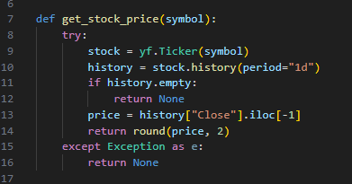

* Gets the latest daily closing price of the given stock symbol.
* Returns None if the stock symbol is invalid or data is unavailable

**4. Route for Home Page**

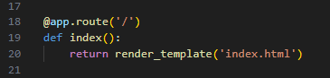

* **@app.route('/'):** Defines the home route **(http://localhost:5000/).**
* **render_template('index.html'):** Renders the index.html page.

**5. API Route to Fetch Stock Prices**

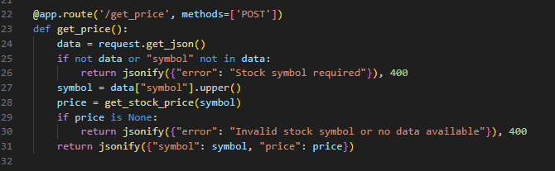

* Accepts POST requests with JSON { "symbol": "AAPL" }.
* Calls get_stock_price(symbol), and returns:
* {"symbol": "AAPL", "price": 150.23} if valid.
* {"error": "Invalid stock symbol"} if invalid.

**6. Running the Flask App**

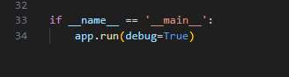

* Runs the Flask server at http://127.0.0.1:5000/.
* debug=True: Enables debugging (shows errors in the browser).